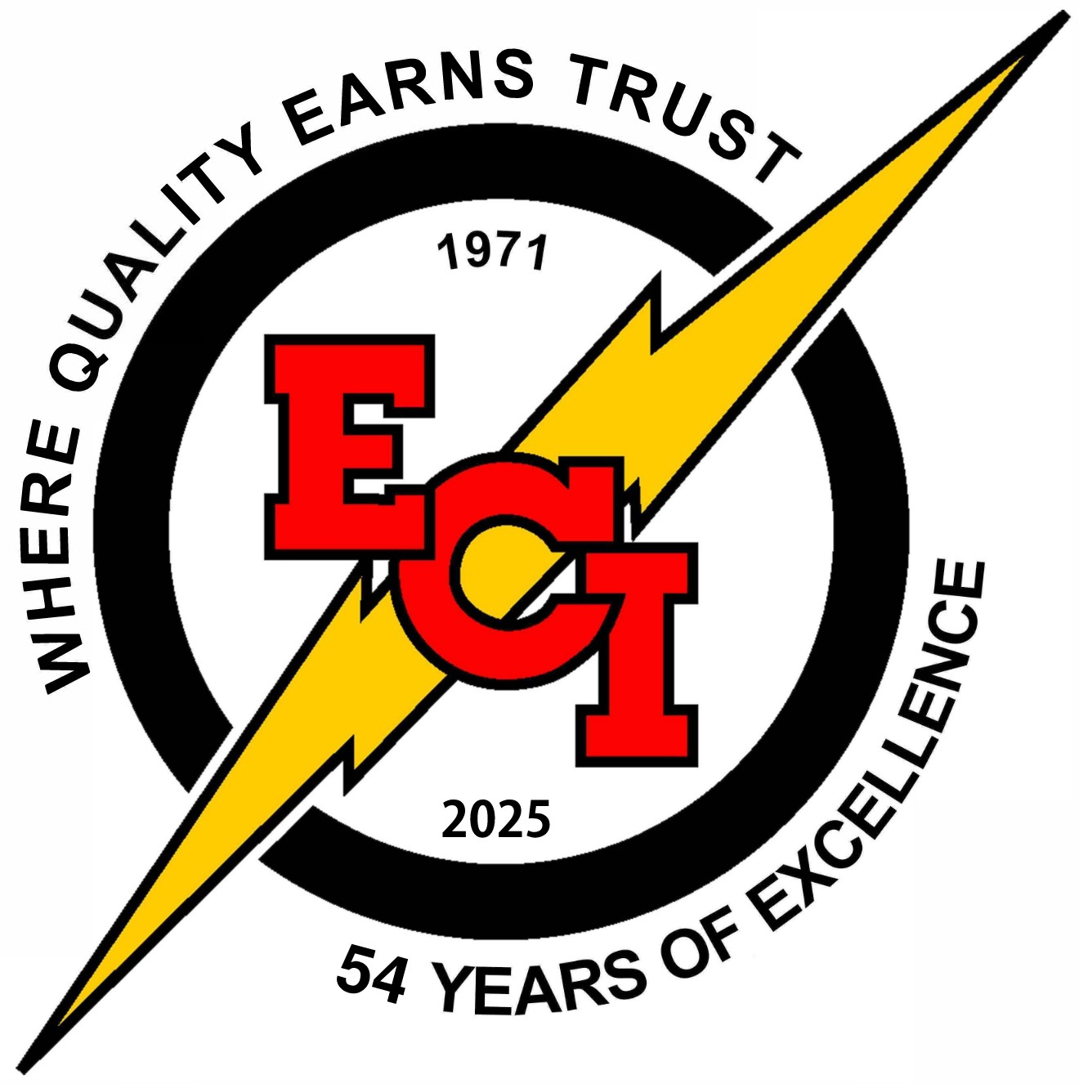
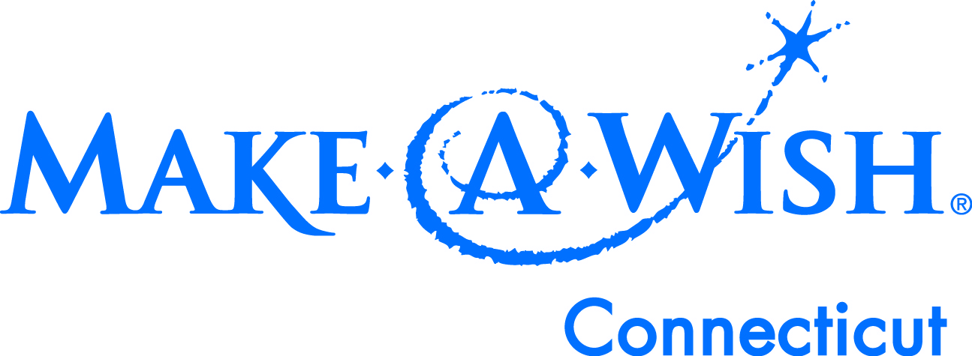

^{35th} Annual
Electrical Contractors LAST OFFICIAL Golf Tournament
Friday, October 2, 2026
Benefiting
Make-A-Wish® Connecticut

TOURNAMENT FORMAT
SCRAMBLE

Blackledge Country Club
Hebron, CT
10:30AM Shotgun Start

PRIZES!!!
Team Prizes
Raffles
Hole-in-One
Longest Drive (M&W)
Closest to the Pin (M&W)
Putting Contest
50/50 Drawing

$200/player
All Sponsorships include Tee Sponsor:
Platinum - $2,000 (Includes foursome) Gold - $1,500 (Includes 3 players)
Silver - $1,250 (Includes 2 players) Bronze - $1000 (includes 1 player)
Tee Sponsor - $500 Dinner Only - $100
Please consider donating for our raffle, all items are welcome
Including electronics, tools, gift cards and golf equipment.
100% of the raffle benefits the Make-A-Wish Foundation
Check payable to Electrical Contractors, Inc. or pay by credit card. Reserve your place TODAY by email to golfouting@ecincorporated.com.

ENTRY DEADLINE: Friday September 25, 2026

Tournament Includes:
Greens Fees, Cart, Box Lunch, Buffet Dinner and 2 Drink Tickets

Player 1:____________________________ Organization/Company_____________________________
Phone:_____________________________ Email:________________________________
Player 2:____________________________ Organization/Company_____________________________
Phone:_____________________________ Email:________________________________
Player 3:____________________________ Organization/Company_____________________________
Phone:_____________________________ Email:________________________________
Player 4:____________________________ Organization/Company_____________________________
Phone:_____________________________ Email:________________________________
Sponsorship Amount:_____________ Dinner Only ___ @ $100=______ Golfers ______@ $200=______
Total Amount Due:$_____________

